**Beginners Guide for**

**Docker Handy Tool**

Hey guys Moonwalker is here to help you in solving all complex docker tool commands.

I have made a program using #python_language #Docker_Handy_tool, an attempt made to solve the problems faced by newbies in containerisation world if they just want to deploy services via containers but they dont know how to operate on #docker .

Docker Handy TOOL is an attempt to create an easy an simple way to do various operations on containerisation technology through docker tool.

This program has 15 different services ready to be used in any #Redhat_8 OS in the world! As we know docker community-edition can't be downloaded in #RHEL_8 but using Docker_Handy_Tool you can dowload the same and run various containers and do your work.

You have to pull/download/clone this repository and run the program name :- “handy.py” on CLI using command

“python3 handy.py”

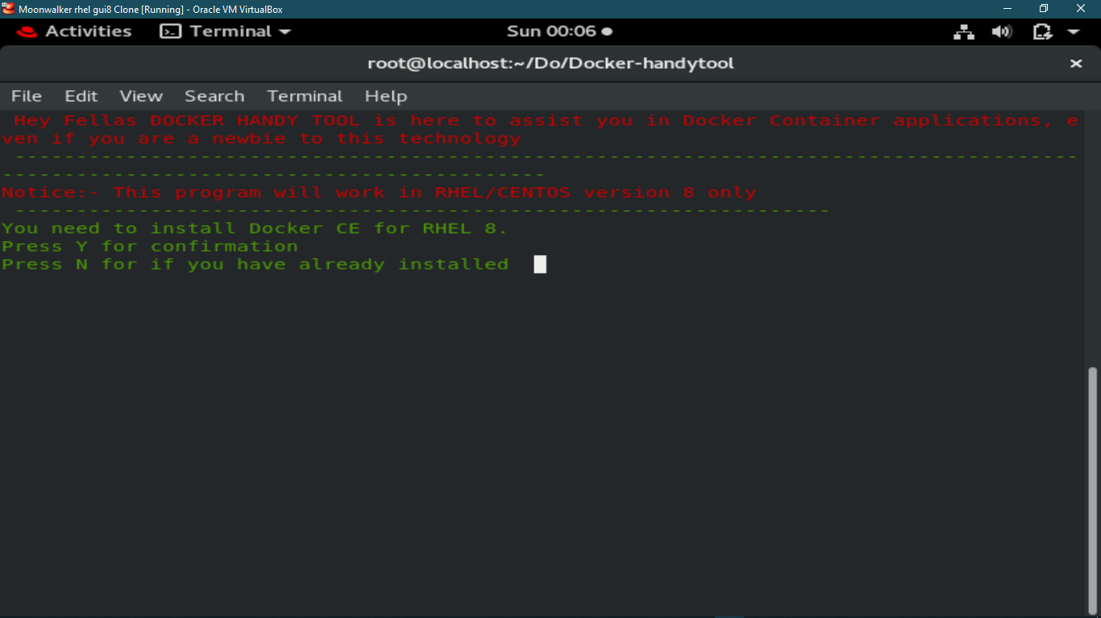

After running this is the first thing docker handy tool would ask. If you don’t have Docker-ce installed press Y it will be installed otherwise press N if you already have docker-ce available in your OS and proceed to see next services.

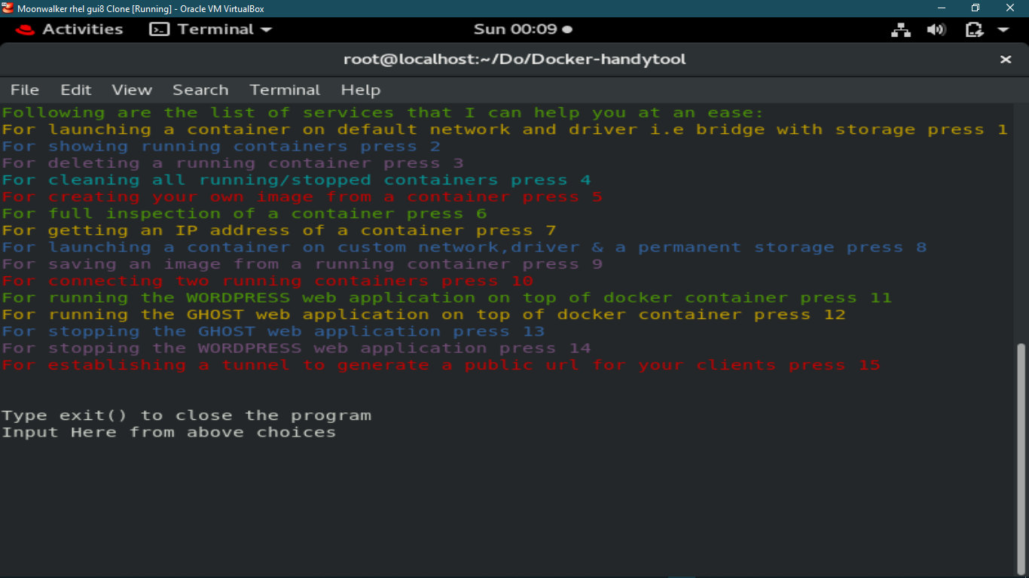

The next screen you see is all the services that this tool would help you in operating you docker tool without knowing docker commands. You have to read options and press on number choices accordingly which type of operations you want to perform.

Some key services of this program

* Installing docker-ce on top of RHEL_8
* Downloading desired Docker images from the registry.
* Running containers just by taking input of desired name user want to provide and image along with its version (user will be given different chocices to fill all these by displaying the list of images available if the image is not available it will download from the docker hub/registry).
* Getting Ip address of a container just by putting names.
* Removing, Inspecting, Connecting different OS
* Launching Web application Infrastructure of Wordpress linked with mysql:5.7 database with an ease.
* Launching Web application Infrastructure of Ghost linked with mysql:5.7 database with an ease.

**An additional tool “ngrok” is also provided to use inside this program which takes input of the port number and protocol of the web application or website running on server.**

**Through this the user can host his/her website to outside world by creating a tunnel with just one enter key pressed and the public url generated can be provided to the clients across the Globe eliminating issues of getting a domain or public url from ISP.**

**Thank You for your visit on my repository!**